**Resolving Conflicts**

**Scenario**

Created a new project to do this called JoeSteelePerkinsTest.

On the master branch I created a file called File1.txt

Then created a new branch; Branch1. On that branch I made a change to File1 and also created a new file called Branch1 file.txt.

Then I created another branch; Branch2. On that branch I made a different change to File1 and also created a new file called Branch2 file.txt.

My objective is to merge Branch1 into Branch2

**Test 1 – resolving conflicts in GitLab using destination version of conflict file**

**Don’t** try to merge in SourceTree first.

Create a Merge Request in GitLab

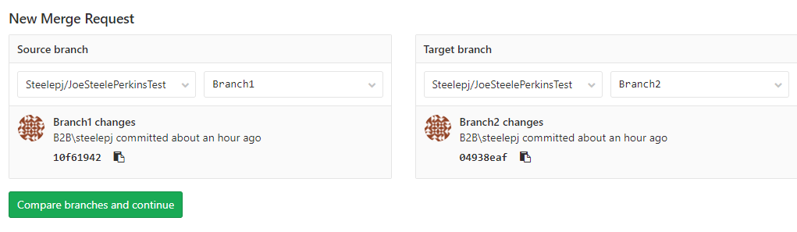

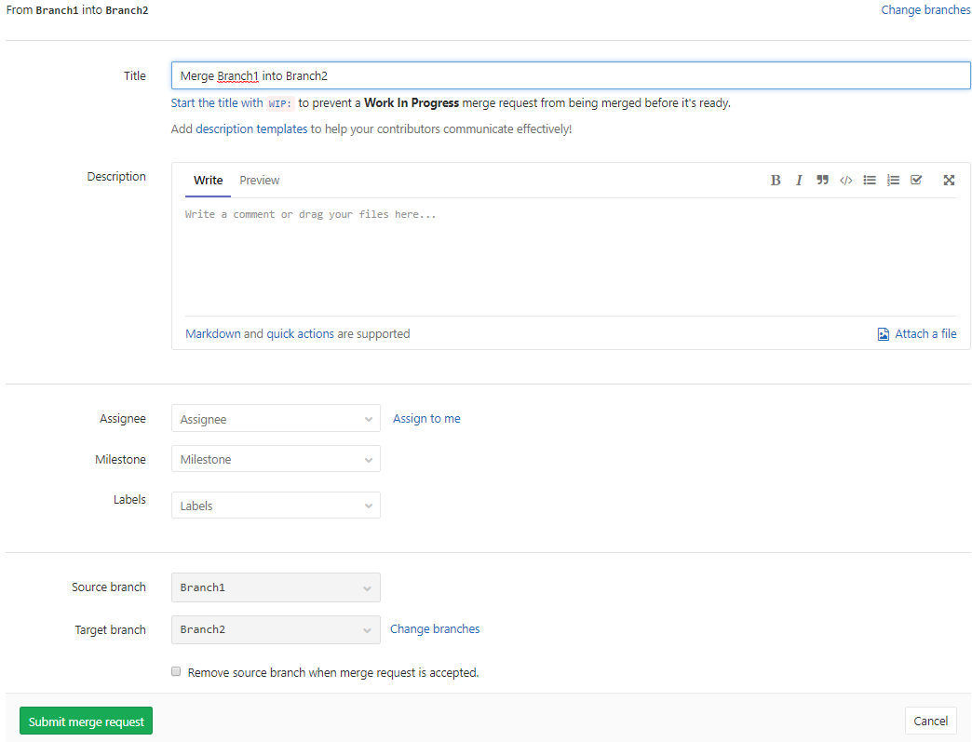

As I’d expect, it is telling me there are conflicts…

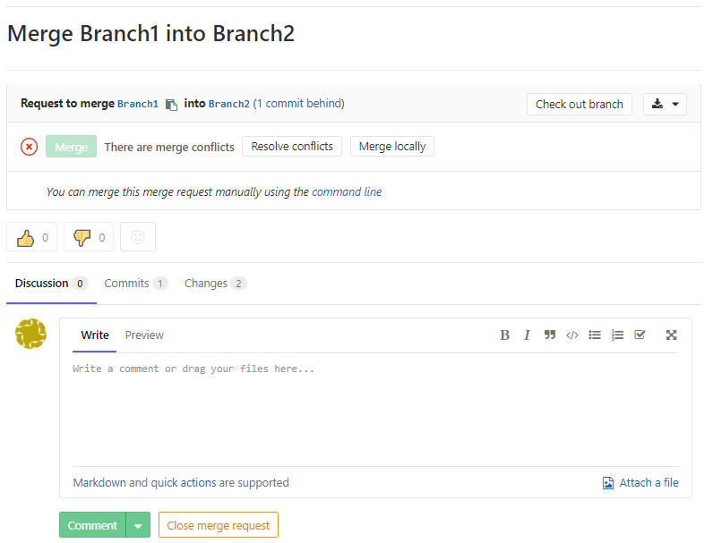

So I show the conflict. Not that the Commit message is now “Merge branch ‘Branch2’ into ‘Branch1’???

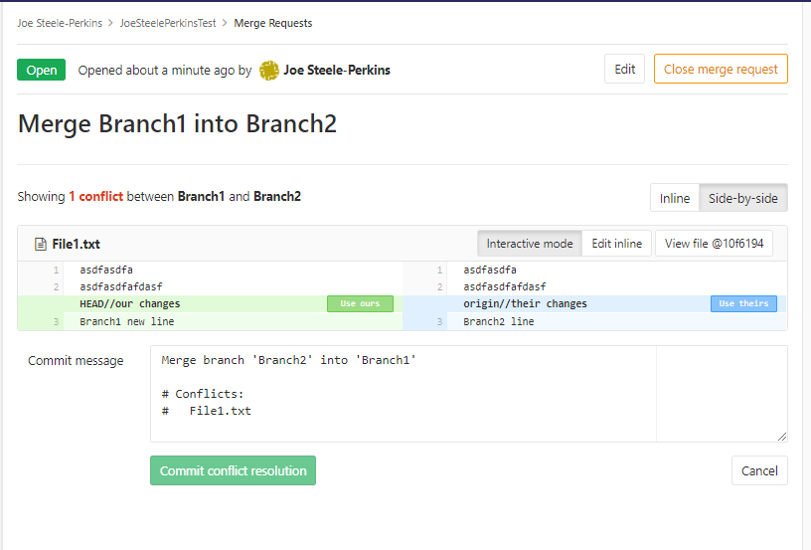

I’m going to choose to keep Branch2 changes (but this shouldn’t make any difference)

I then get this message…

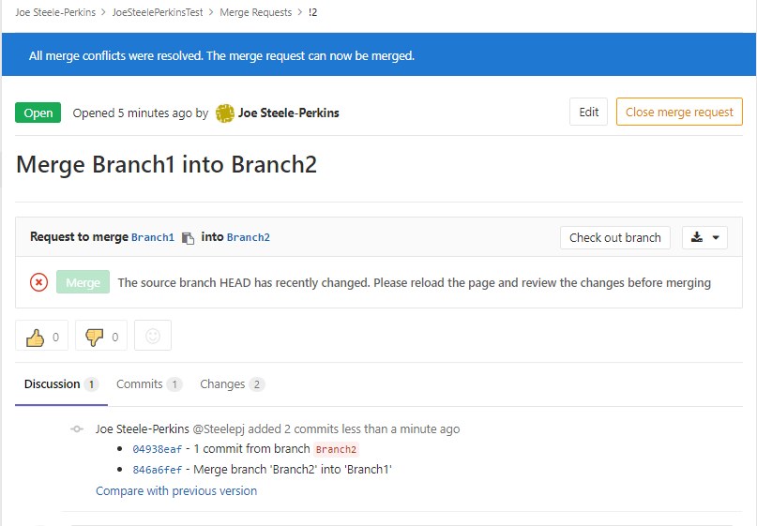

I don’t think the merge has taken place because of this message…

**The source branch HEAD has recently changed. Please reload the page and review the changes before merging**

So I refresh the page and press Merge.

So what has happened?????????????.

I’m going to check in GitLab so I don’t get into a mess in SourceTree. This is what has happened in the destination branch ie Branch2

* The conflicted file has been handled correctly ie it contains Branch2 change

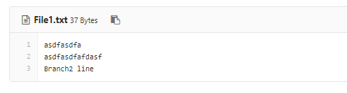

* And Branch 1 files has been added to Branch 2

This is what has happened in the source branch ie Branch1

* The conflicted file has been changed. That shouldn’t have happened
* And Branch2 file has been added to Branch1. That also shouldn’t have happened

And in the Commit list for Branch1 it clearly say that Branch2 has been merged to Branch1.

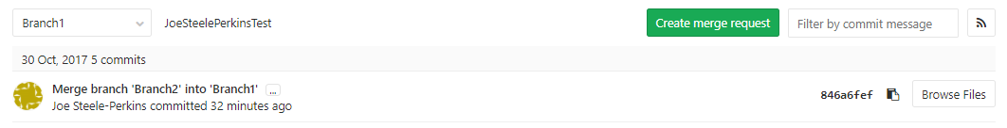

**Test 2 – merging in Gitlab without a conflig**

Created another new file in Branch1 and in Branch2.

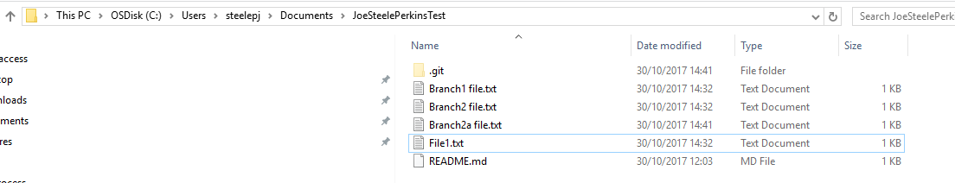

Create another Merge Request in GitLab, again Branch1 to Branch2.

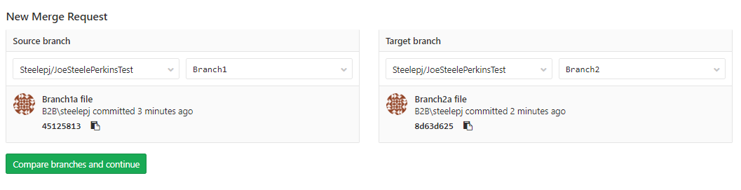

No conflicts, the merge is ready to run.

And this time the merge was done correctly.

**Test 3 – resolving conflicts in GitLab using source version of conflict file**

Added another file to each branch and created a conflict again in File1.

Conflicts were identified.

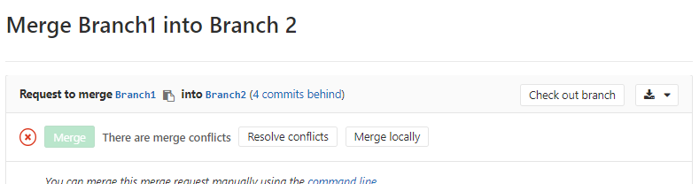

Conflicts resolved this time by selecting the version in Source Branch (Branch1)

I haven’t run the merge yet but look there is already a commit…

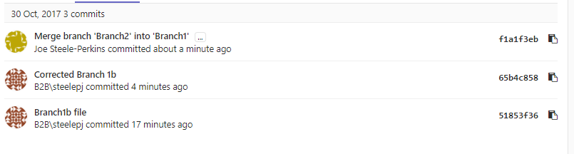

Exactly the same thing happened. Branch1 contains Branch2b file which it shouldn’t have.

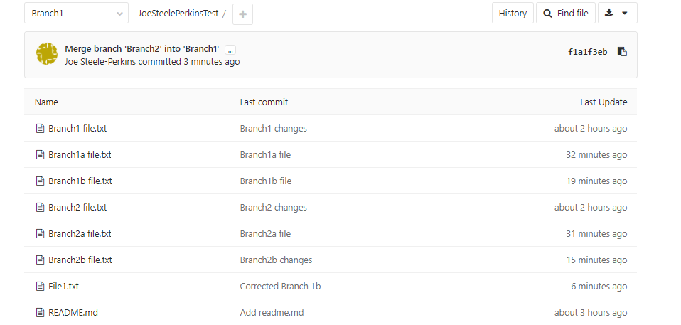

**Test 4 – try to not use Gitlab at all**

More new files in the branches and amended File.txt.

Merged using SourceTree then got this message

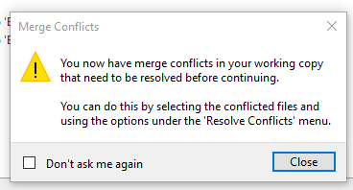

What happens when this message comes up is that the conflicted file is updated. In the below, HEAD shows what is in the checked-out branch, Branch1 is what is in the source branch. You can see what files the conflict is in by looking at the Uncommited changes line

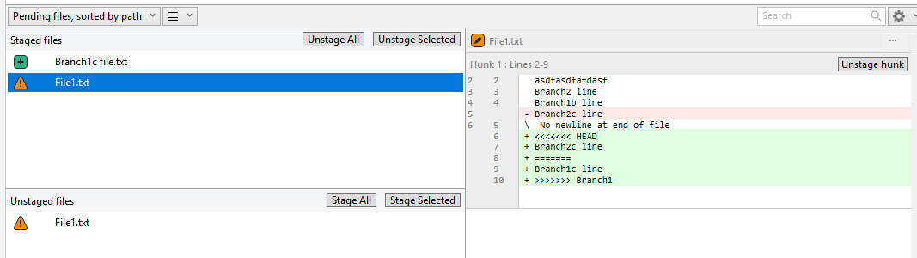

Manually update the file so what is left in the file is what you want to keep so from…

asdfasdfa  
asdfasdfafdasf  
Branch2 line  
Branch1b line  
<<<<<<< HEAD  
Branch2c line  
=======  
Branch1c line  
>>>>>>> Branch1

Change to (if you want to keep what is in Branch1) the below…

asdfasdfa  
asdfasdfafdasf  
Branch2 line  
Branch1b line  
Branch1c line

Submit the change